# Guidelines for Node js Installation and Setup

## Step 1: Download the installation files from the Internet

Start the browser of your PC and the latest version of Node js that is to be installed is searched.

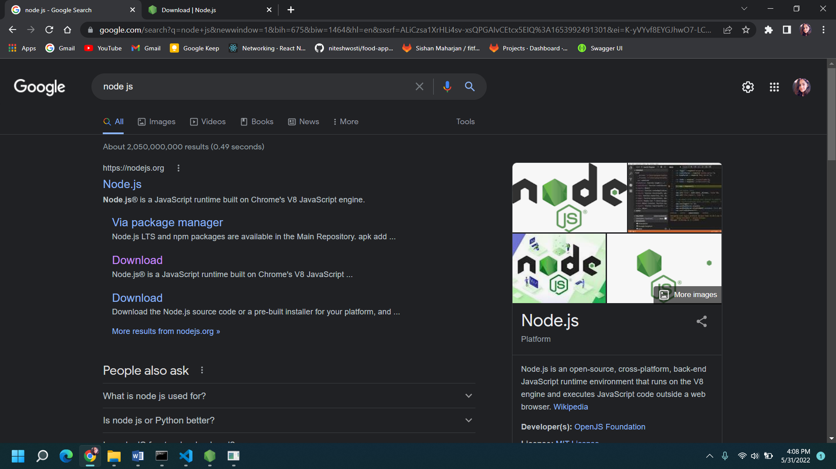

The software that is selected is done using the OS version of your device.

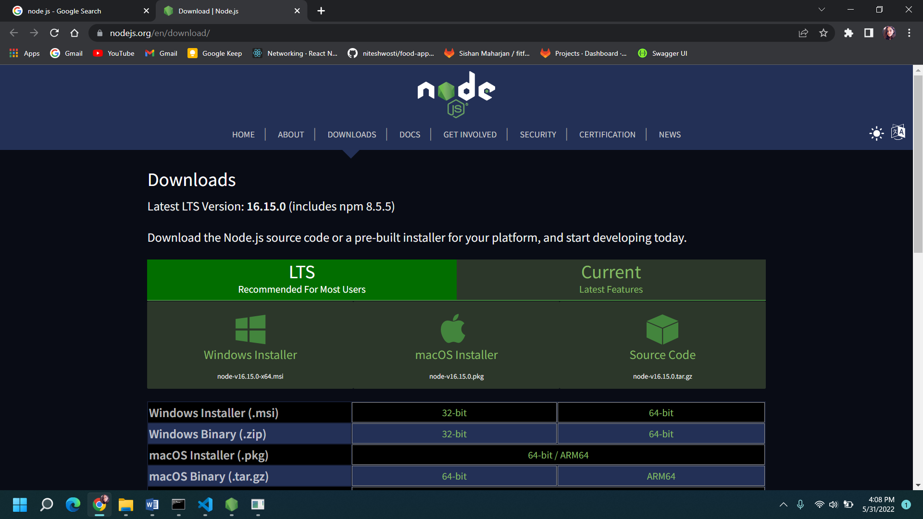

## Step 2: Start the setup wizard

After you continue with the setup, there is an appearance of the set up wizard dialog box, where you click on the checkbox agreeing to the terms and conditions and click ‘Next’ to configure further installation process.

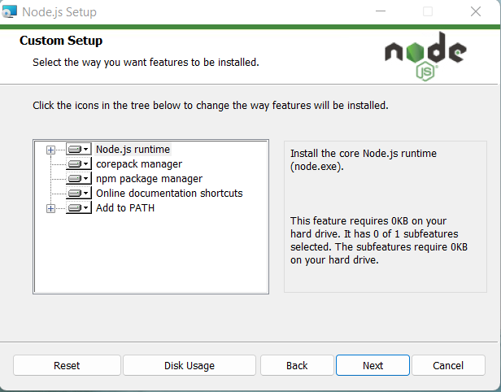

## Step 3: Complete Installation

After the software has been installed, a dialog box is displayed that specifies the user about the completion of installation process. When the ‘Finish’ button is clicked then the process will end.

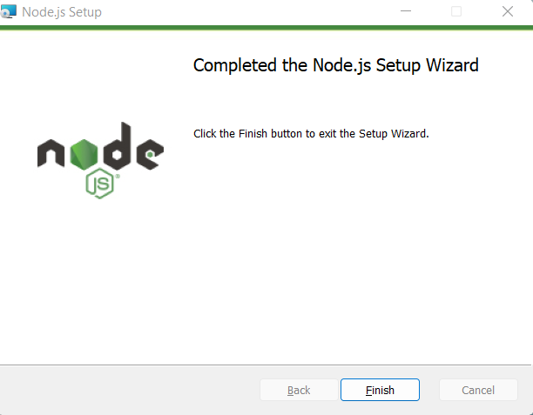

For further installation of tools:

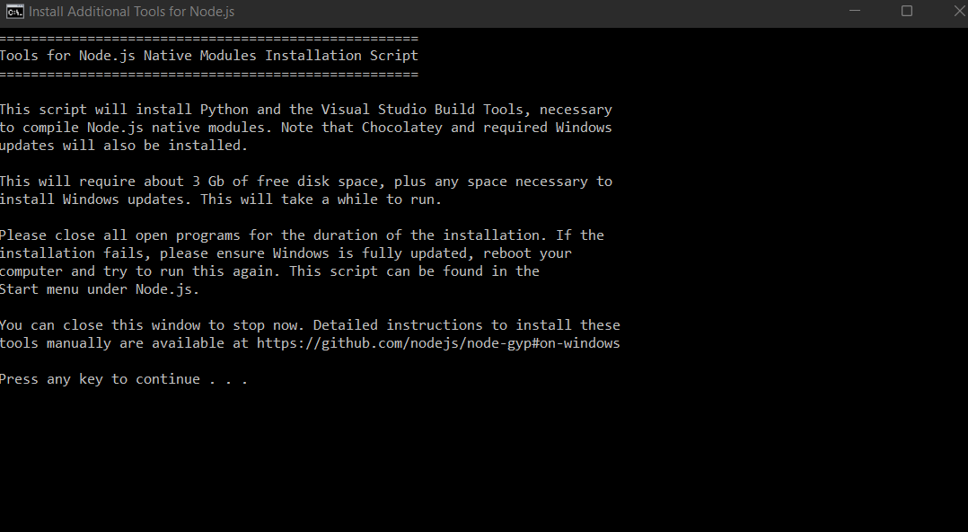

Running node js

